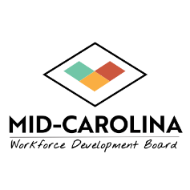
MID-CAROLINA REGIONAL COUNCIL
BOARD OF DIRECTORS
MEETING NOTICE

Notice is hereby given that the Mid-Carolina Regional Council Board of Directors will hold a meeting at 12pm on Thursday, August 27, 2026. This meeting will be held virtually, with attendance as permitted by North Carolina law and the Board’s Bylaws.
The purpose of this meeting is to conduct regular business of the Mid-Carolina Board of Directors, including the review of reports, discussion of ongoing initiatives, and consideration of matters requiring Board action.
Those wishing to attend the meeting may attend in person at Coats Town Hall, 25 E. Main Street, Coats, NC 27521 or may participate through Zoom. Zoom log-information is as follows:
Topic: Mid-Carolina Regional Council Board of Directors Meeting
Mary Beth Bird is inviting you to a scheduled Zoom meeting.
Join Zoom Meeting
https://zoom.us/j/97404939235?pwd=aEJxF21xYRnXketSADND3GeiBkH8Gb.1
Meeting chat link
https://zoom.us/launch/jc/97404939235
Meeting ID: 974 0493 9235
Passcode: 942170
One tap mobile
+19292056099,,97404939235#,,,,*942170# US (New York)
+13017158592,,97404939235#,,,,*942170# US (Washington DC)
Join by SIP
• 97404939235@zoomcrc.com
Join instructions
https://zoom.us/meetings/97404939235/invitations?signature=RKQzXkVpxjL0AJILuY7cXh2Dpc7LPf2Jx1kyGDV6Hr8

